ellis EVENTS
– CONNECTING THE WORLD THROUGH EVENTS
As a family-run company, ellis EVENTS stands for unique events worldwide. ellis EVENTS has been offering full service for corporate events for 35 years. From the first idea to the final invoice, you receive all services from one single source.
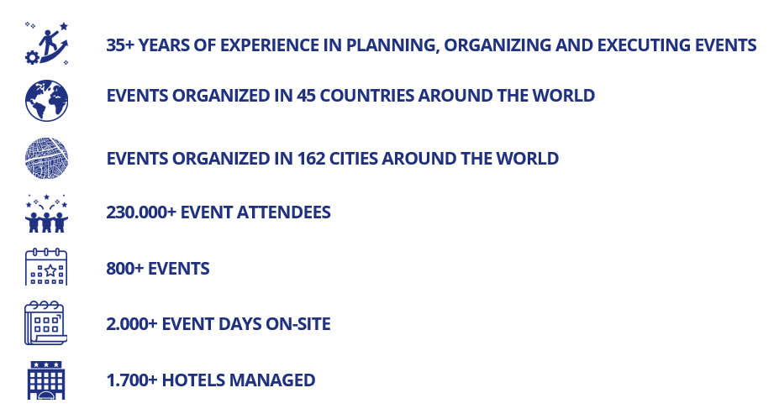
We have been realizing exceptional events in a scale from 10 to 13.000 attendees in over 40 countries and in more than 160 cities worldwide.
- Congresses & Meetings
- Trade Fairs & Exhibitions
- Roadshows
- Incentives & Teambuilding
- Corporate Events
- Destination Management
- Creative work & Design
- IT & AV
- Delegate Handling
Share your wishes and goals with us. Let’s work together to realize a successful event which you and your guests will remember for a long time.
CONNECTING THE WORLD THROUGH EVENTS
We look forward to seeing you at IMEX
23- 25 May 2023 in Frankfurt.

