EUROPE’S LARGEST* OUTLET OPENS
MOXY OUTLETCITY METZINGEN HOTEL

On 12 December in Metzingen, the doors to the Moxy Outletcity Metzingen hotel were opened. On 01 February, Outletcity AG celebrated this new milestone with an evening event and opened the new Outletcity Welcome Center together with VIP guests and famous celebrities. The musicproducer, Mousse T., spun records as DJ for the music entertainment, while Frauke Ludowig moderated the evening.
Moxy Outletcity Metzingen
The fashion and lifestyle hotel is operated by Odyssey Hotel Group, a white label operator of the renowned global hotel brand Marriott International. Odyssey Hotel Group's portfolio includes 23 hotels across Europe.
The target group includes a audience interested in fashion and lifestyle, international groups looking to stay overnight after a tour of Outletcity, business guests and also visitors who are interested in exploring the region. The hotel provides everything needed for a longer stay in Outletcity and the surrounding area.
The hotel, which is located in the centre of the Outletcity, was realised by the blocher+partners architecture firm and was finished within 20 months of construction. “From an urban planning perspective, the Moxy is like a piece of the puzzle: as a hotel, it rounds off
Outletcity and enriches the customer experience. We brought the glamour and style of this special location into the interior; the lobby reflects the fashion world that surrounds it“ so Anja Pangerl, partner blocher+partners Stuttgart.
Fashion is the motto at Moxy Outletcity Metzingen. Playful, yet stylish details give the hotel a unique and individual character. Elements like spools of thread, mannequins or coat hangers are tastefully arranged and make the connection to all of Outletcity Metzingen with its unique history. At Moxy Outletcity Metzingen, style meets comfort, design and hospitality.
The extraordinary lobby serves as the centrepiece of the hotel and is designed to resemble a fashion runway. “It is a fantastic offer for our regional and international guests. The attractive design fits perfectly in the ambience of the most successful outlet in Germany and it furthers our claim as a destination for events and experiences.” – Wolfgang Bauer, CEO of Outletcity AG.
Another highlight at the hotel is the view of the most famous international premium and luxury brands, with a close natural backdrop. Thanks to the excellent location in the middle of Outletcity, the guests don’t need to go far to reach Germany’s number one outlet.
Food & Beverage
The spacious and comfortable hotel lobby also features the Moxy Bar. Available for hotel and Outletcity guests alike, here is where modern co-working space meets urban area with table foosball, board games and community tables.
Parking
Overnight guests of Outletcity Metzingen have the option of parking their car in any of 50 VIP parking spaces, including six new charging stations for electric vehicles in the parking garage P1. These are accessible via the lobby elevator in the hotel.
High end hospitality in the heart of the city– the new Outletcity Welcome Center
The new, 600m2 Outletcity Welcome Center also calls the new building home. Guests are greeted here with an open ear for any questions alongside conveniences of all kinds. The modern look and feel is functional and cosy, achieving a warmly inviting aesthetic.

Numerous services are available at the Welcome Center:
The Lounge
is a space explicitly for Outletcity Gold club members. These can reserve the room for a shopping break in a cosy atmosphere, while enjoying canapes and select drinks.
The Atelier
Here, guests can enjoy the pleasures of shopping privately with a professional personal assistant. In particular, the luxury brands are able to present their wares to customers. The Italian luxury brand, Prada, will be the first to decorate the space.
The Studio
This room offers an open floor plan to facilitate the reception of groups. The space is also available as a function room for external company events upon request. The room is equipped with all of the necessary peripherals such as a projector screen, microphones and sound systems.
Tax-Refund
As already available in the previous Welcome Center on Hugo Boss Platz, international guests have the option of having the VAT tax refunded on the premises. Just as before, this service is implemented in the new Welcome Center. In cooperation with Global Blue and Planet, the VAT tax can be refunded directly to the credit card. This is excellent for guests who wish to avoid long waits at the airport.

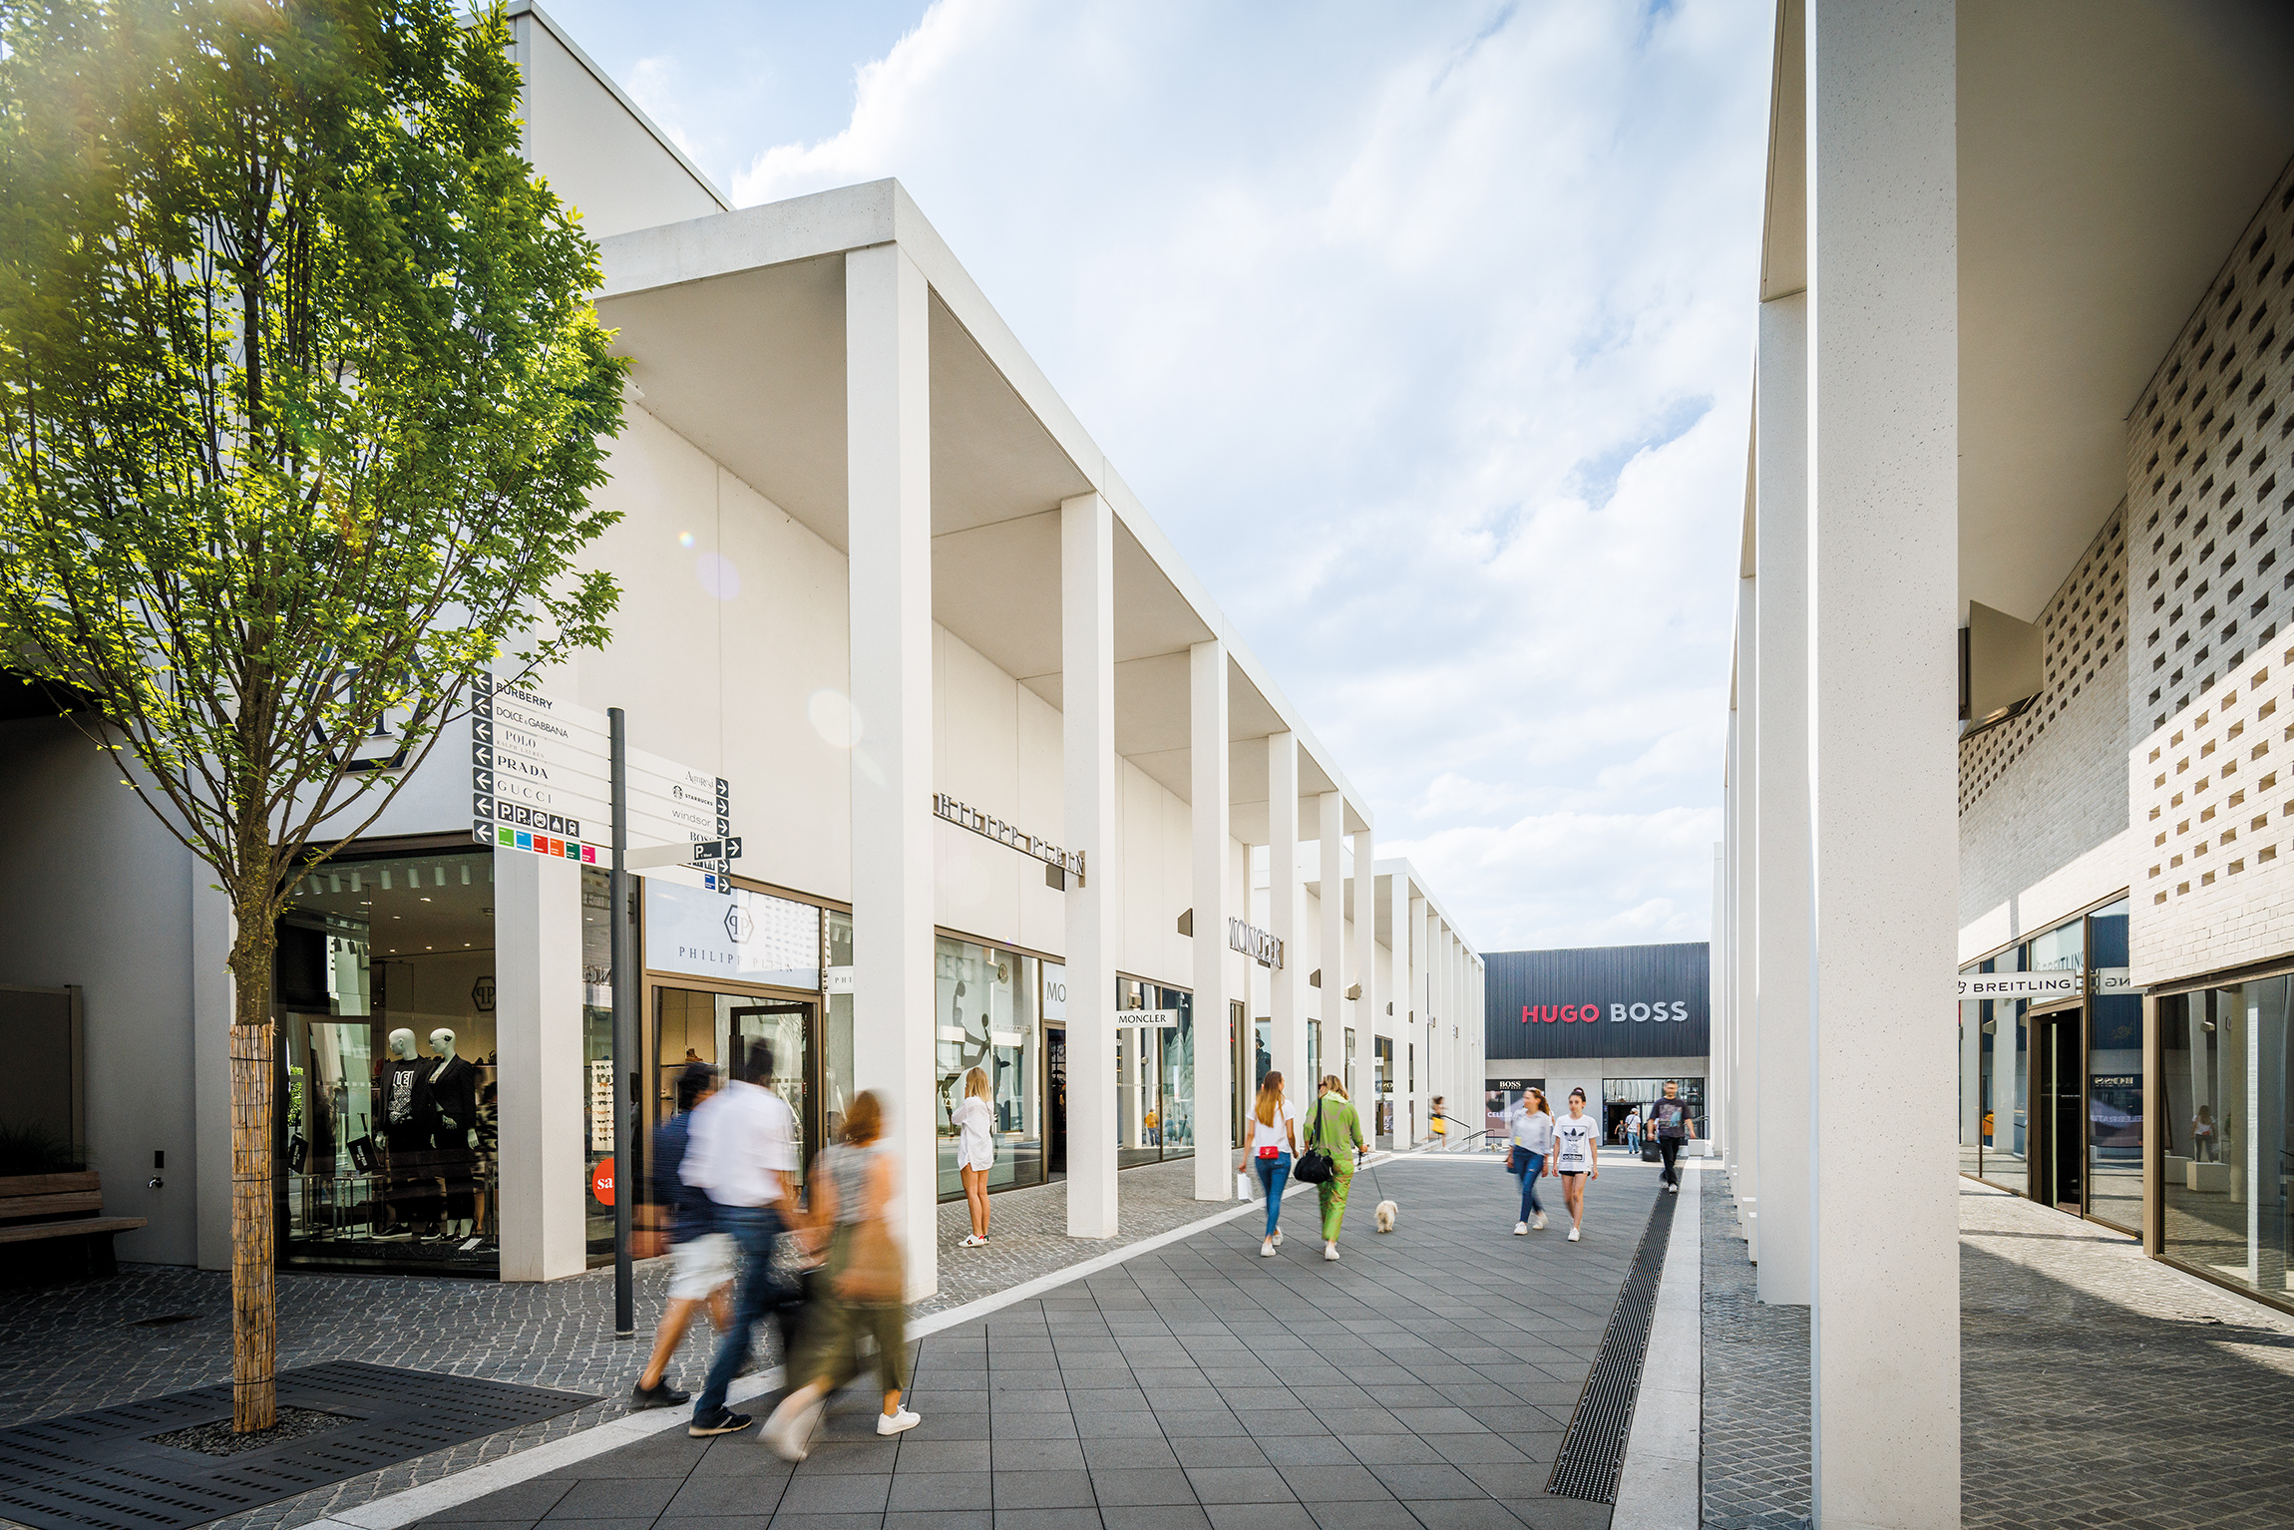

Brand portfolio
Internationale Premium- und Luxury brands

7 For All Mankind
Adidas
American Vintage
Aigner
Alberta Ferretti
Armani
Babor
Bahlsen
Balenciaga
Bally
Bogner
Boss
Bottega Veneta
Breitling
Burberry
Calvin Klein
Closed
Coach
Coccinelle
Columbia
Crocs
Desigual
Diesel
Docker
Dolce & Gabbana
Douglas
Dsquared2
Dr. Martens
Ecco
Esprit
Estella
Fabiana Filippi
Falke
Fossil
Furla
FTC Cashmere
G-StarRaw
Gant
Gucci
Guess
Hackett
Haribo
Hogan
Home & Cook
Hour Passion
Hunkemöller
Jack & Jones
Jimmy Choo
Jil Sander
Joop!
Karl Lagerfeld
Kate Spade
Kennel & Schmenger
Kjus
Kneipp
L’Occitane
Lacoste
Lee
Le Creuset
Levi’s
Liebeskind
Lindt
Longchamp
Lululemon
Mammut
Marc O’Polo
Max Mara
MCM
Mey
Michael Kors
Missoni
Moncler
Moschino
Motel a Miio
Möve
Nike
Oakley
Olymp
Only
Pandora
Patrizia Pepe
Paul & Shark
Peak Performance
Philipp Plein
Polo Ralph Lauren
Porsche Design
Prada
Puma
Ravensburger
Ritter Sport
Roberto Cavalli
Rösle
las.Oliver
Salvatore Ferragamo
Samsonite
Sandro
Schiesser
Scotch & Soda
Seidensticker
Skechers
Storck
Strellson
Sunglass Hut
Superdry
Swarovski
Ted Baker
The Cosmetics Company Store
The North Face
Thomas Sabo
Timberland
Tod‘s
Tom Tailor
Tommy Hilfiger
Tory Burch
Tumi
UGG
Under Armour
Valentino
Vero Moda
Versace
Vilebrequin
Watch Station
Windsor
WMF
Woolrich
Wrangler
Zwilling

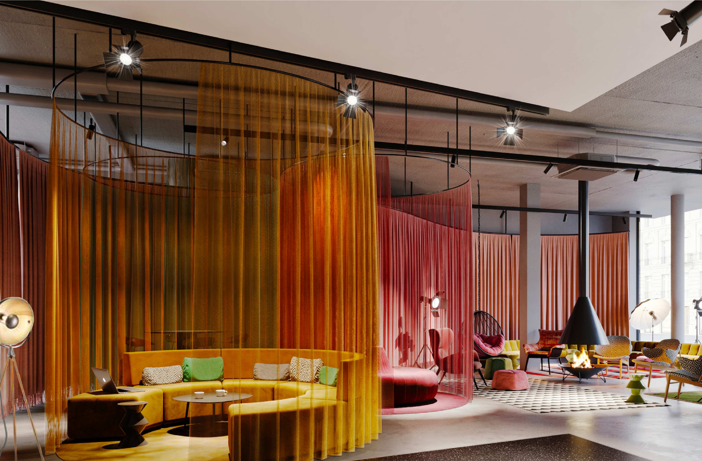

About

Odyssey Hotel Group
Odyssey Hotel Group, founded in 2012 in the Netherlands encompasses a distinctive portfolio of 23 hotels providing over 3,500 rooms within Europe, and 25 properties currently in the pipeline. As white label operator of respected global hotel brands, Odyssey Hotel Group leverages deep understanding of the hotel and hospitality market, and the connection with the European real estate industry. In December 2020, Activum SG joined Odyssey as the major shareholder. Odyssey Hotel Group is powered by over 750 people providing exceptional service, keeping a close eye on every detail and serving our guests with flair and ease.
www.odysseyhotelgroup.com | LinkedIn @Odysseyhotelgroup

Blocher partners
Founded in 1989, blocher partners has developed into a transdisciplinary planning office that successfully realizes national and international projects. Around 250 employees from 15 different disciplines, including architects, interior designers, communication specialists, graphic designers and design strategists, work hand in hand at the four locations in Stuttgart, Berlin, Mannheim and Ahmedabad (India).
Always with the aim of finding the best design solutions for our clients' requirements.

Outletcity Metzingen
A study by the independent ecostra consulting company awarded Outletcity Metzingen as Europe’s largest outlet*. The exclusive brand portfolio of Outletcity Metzingen is presented in award-winning architecture in an authentic and urban environment. With 500 premium and luxury brands in Metzingen and on the Online Shop, top service and a well-rounded tourism programme, Outletcity takes its place as number one outlet in Germany. With 4.2 million guests from 185 nations visiting Metzingen annually, the outlet is a true international fashion metropole.
Digital offers such as the Online Shop, Outletcity App and the Outletcity Club connect the brick and mortar and digital shopping worlds to form a unified experience where the guest is the focal point.

